WPSU Community Engagement Strategy Discussion 11/2/2020
Attending: Sherry DelGrosso, Jenn Judd, Sara Songer, Ilona Ballreich, Laura Miller, Carolyn Donaldson
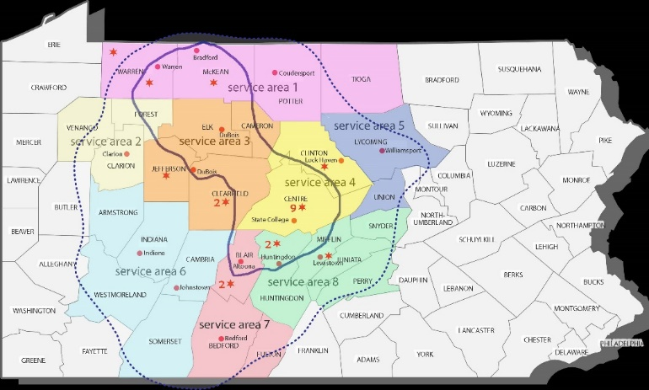

Service Area 1
Counties: Warren, McKean, Potter, Tioga
Hub locations: Warren, Bradford, Coudersport
Service Area 2
Counties Venango, Forest, Clarion
Hub Location: Clarion
Service Area 3
Counties: Elk, Cameron, Jefferson, Clearfield
Hub Locations: DuBois
Service Area 4
Counties: Clinton, Centre
Hub locations: State College, Lock Haven
Service Area 5
Counties: Lycoming, Union
Hub location: Williamsport
Service Area 6
Counties: Armstrong, Indiana, Cambria, Westmoreland, Somerset
Hub locations: Indiana, Johnstown
Service Area 7
Counties: Blair, Bedford, Fulton
Hub locations: Altoona, Bedford
Service Area 8
Counties: Huntingdon, Mifflin, Juniata, Perry, Snyder
Hub locations: Huntingdon, Lewistown

WPSU 2020–2025 Strategic Goals
GOAL 1. Foster sustainable connections with the communities we serve.
Objective A. Implement a community engagement strategy, framework, and principles.
Action1. Partner with Penn State and external organizations to consult in plan development.
Action 2. Segment WPSU's service area into manageable regions with centralized activity hub locations.
Objective B. Deliver initiatives with inclusion in mind.
Action 1. Review events to ensure deliverables are welcoming to everyone and presented with accessibility options.
Action 2. Collaborate with multicultural groups to recruit volunteers and draw in more diverse participation
Objective C. Establish a network of community leaders and advocates across coverage area.
Action1: Identify and establish regular meetings with community leaders from activity regions.
Action2: Build a network of public service non-profits to deliver and distribute public media materials.

Committee Discussion
1. What do we want to achieve? Scope and Purpose? Distribution or collective vision?
Do we want to solve a problem or need in the community or do we want to work with them to provide free resources and learning?
Jenn: go to higher level existing strategic plan to help guide discussions with leaders. Look at organizations like Lions Club and Rotary. Issues will naturally float to the top. Don’t have to do a deep dive assessment to be useful. Re: historic and diversity. Bedford is not a diverse community. Jenn’s father has done a deep dive into black history in a small town and how residents are related.
Ilona: does our audience reflect the people who live in rural communities? If we have an external org we need to tie in with Extension. Who do we call the leaders in the community? Not necessarily job title. Look for representation across the community.
Ilona: There are changes and unexpected changes in programming that we won’t know until the program is release. We should not try to address community needs.
Carolyn: Our Town deeply tells their stories. Most probably never watch PBS but will watch this. How do we keep them to be a lifelong viewer/member?
Ilona: Form an Our Town cohort and feed them information. Speaking engagements, find ways to be part of the town.
Carolyn: we have emails from storytellers in Our Town. Community Advisory subcommittee to brainstorm about involvement ideas.
Ilona: way to get them started invite those who were participants is OT. Have a reunion of OT heroes.
Sara: Likes idea of getting people who already know us. Spreads out input from different areas. Get some teachers to tell us what worked and what didn’t.
Ilona: Our Town Kids Cut are all grown up now. Reunion of Kids Cut Our Town.
Carolyn: Social media influencers who can get the word out and also provide content.
Ilona: See if board members have people in their community who would be a good fit.
Sara and Jenn: Send out a list of Our Towns before board meeting.
Carolyn: December 10 is next OT Moshannon Valley. Could do a teaser during live pledge.
Sara: Two big actions to work on from this meeting>Input from educators and connecting Our Town.
Ongoing WPSU Engagement Options
StoryCorps
Bookmark
This I Believe
Our Town

